EXPERIMENT 5: Band Structure Simulation for Graphene and CNTs using NanoHub
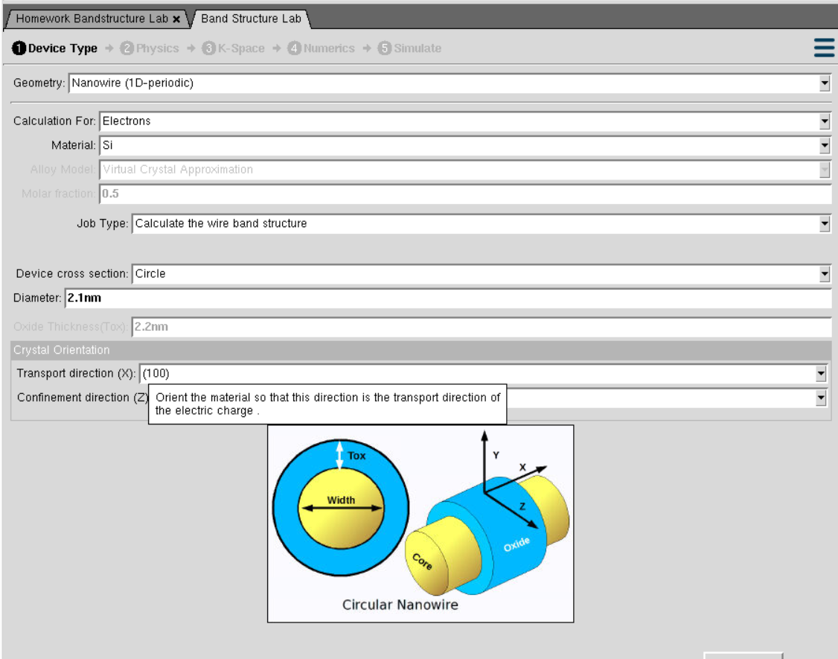
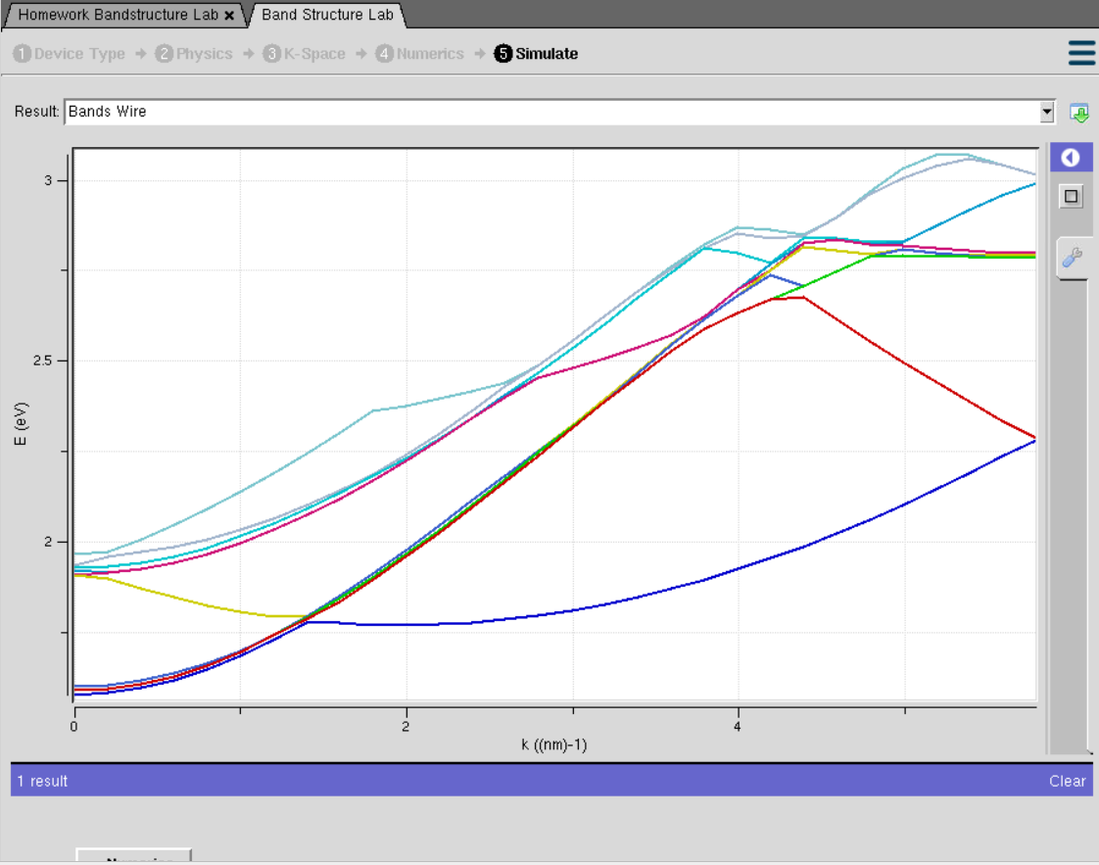
This experiment is performed to study the electronic band structure of graphene and carbon nanotubes (CNTs). It helps understand their electrical properties by analyzing the allowed energy bands and band gaps
Case Study 1: Simulate the band-structure of InAs circular nanowire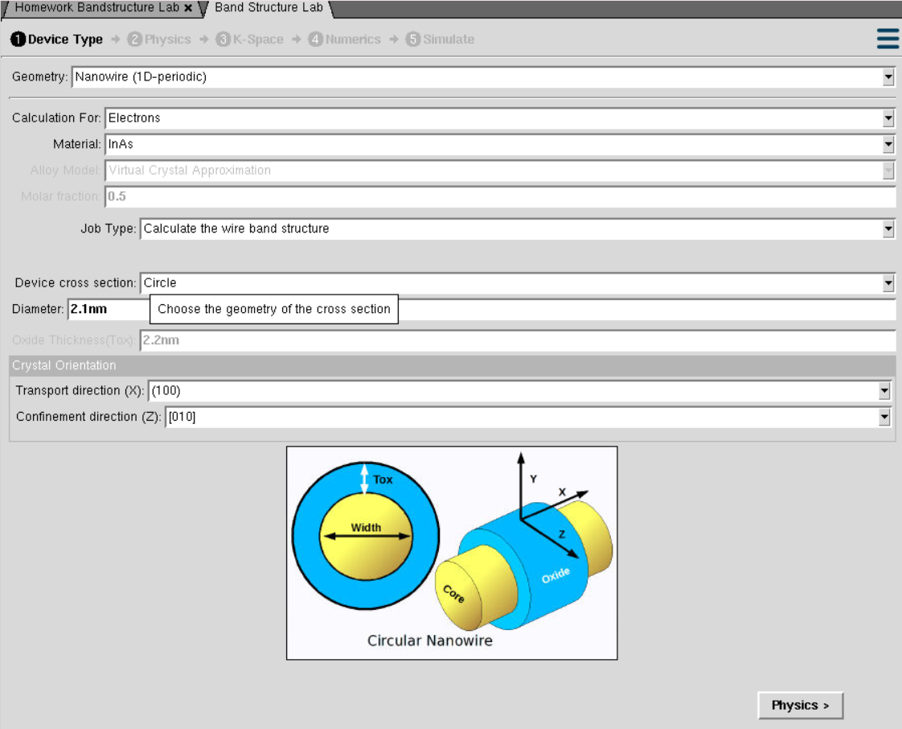
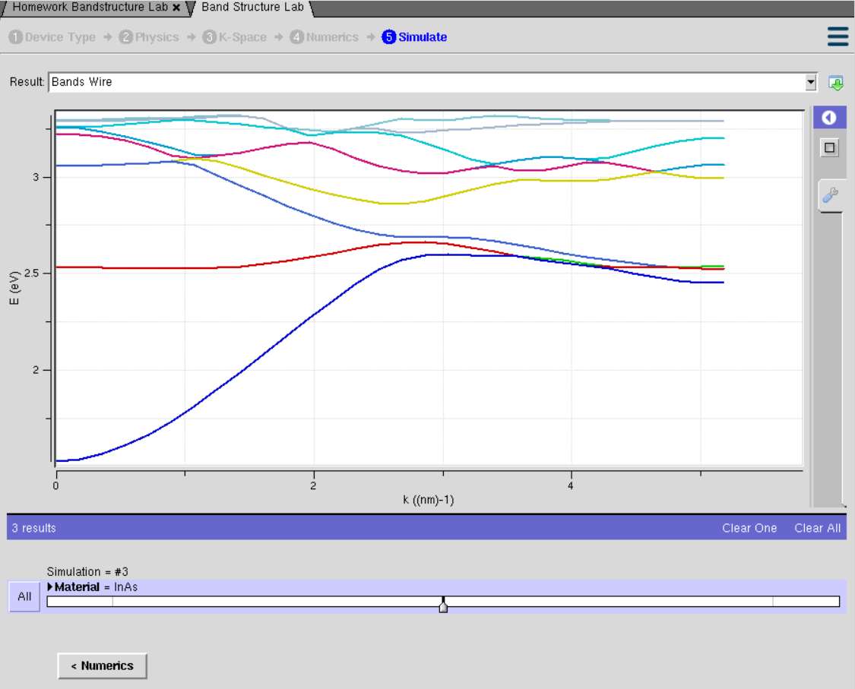

This case study is performed to study the electronic band structure of an InAs circular nanowire. It helps understand how nanoscale confinement affects the energy bands and electrical properties of the nanowire.

CASE STUDY 2: Simulate the band-structure of AlGaAs circular nanowire
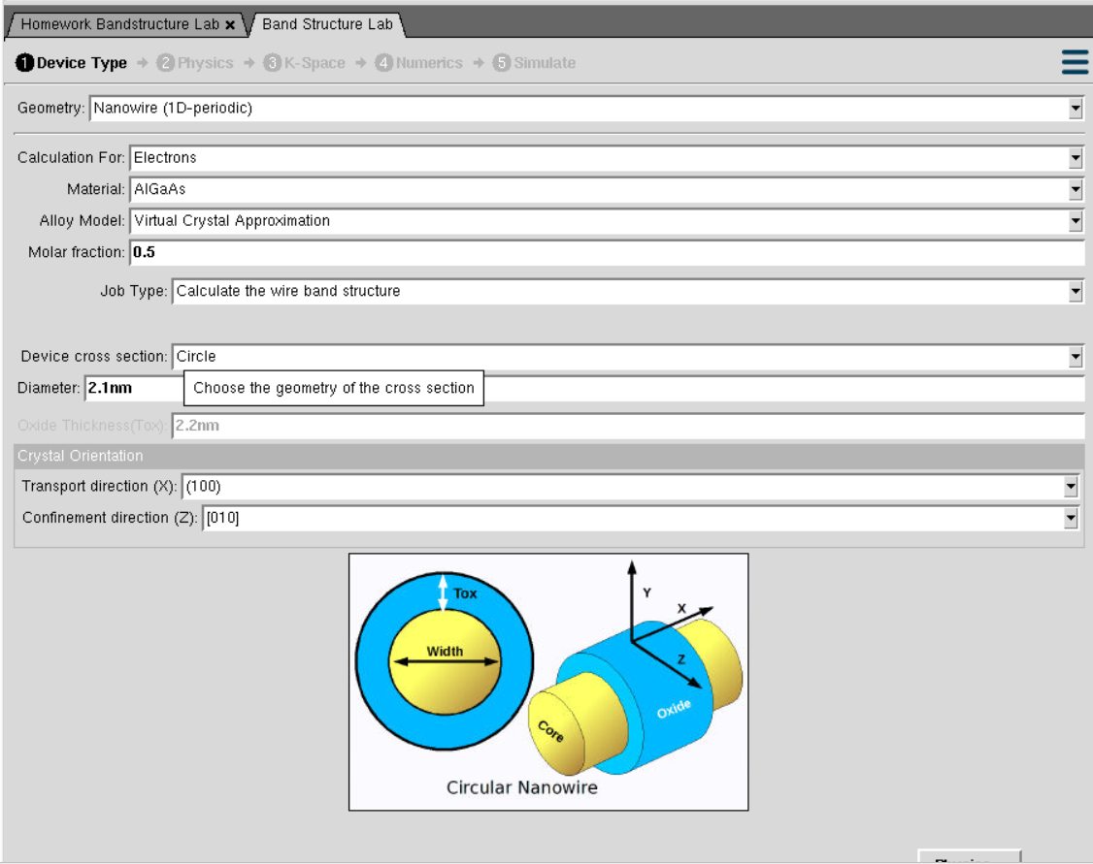
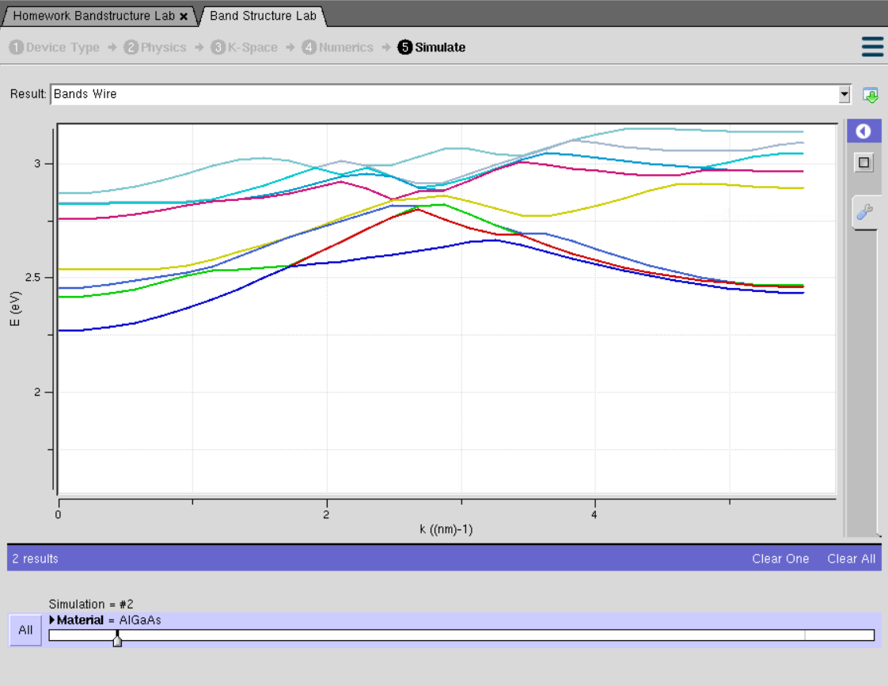
This case study is performed to study the electronic band structure of an AlGaAs circular nanowire. It helps understand how the material composition and nanoscale size affect the energy bands and electronic properties.

